SQL Querying Assignment – Learner Course Purchase
Analysis System
Project Documentation

Project Overview
This project demonstrates the implementation of SQL Query Language and data retrieval operations in MySQL by querying and analyzing a Learner Course Purchase database. The assignment focuses on retrieving, joining, filtering, sorting, grouping, and aggregating learner and course purchase data. It also demonstrates the use of subqueries, Common Table Expressions (CTEs), CASE expressions, NULL handling, and Views to generate meaningful business reports.

Objectives
- Create a relational MySQL database with learners, courses, and purchases tables.
- Define primary keys, foreign keys, and appropriate data types.
- Insert sample learner, course, and purchase records.
- Retrieve related learner, course, and purchase information using JOIN operations.
- Perform sorting, grouping, aggregation, and filtering for business analysis.
- Calculate learner-level and course-level spending and purchase metrics.
- Use subqueries to compare learner spending with overall and country-level averages.
- Use a CTE to calculate total spending per learner.
- Classify learners using a CASE expression based on spending.
- Handle NULL values using IFNULL() or COALESCE().
- Create a reusable category performance View.
- Translate business questions into SQL queries and analytical outputs.

Technologies Used
- MySQL 8.x
- MySQL Workbench
- SQL (DDL, DML & Data Retrieval Commands)

Database Schema

Database
Learner_Course_DB

Tables Used

1. Learners
Stores learner information.
Column | Data Type | Constraint
learner_id | INT | Primary Key
full_name | VARCHAR(100) | NOT NULL
country | VARCHAR(50) | NOT NULL

2. Courses
Stores course information.
Column | Data Type | Constraint
course_id | INT | Primary Key
course_name | VARCHAR(150) | NOT NULL
category | VARCHAR(100) | NOT NULL
unit_price | DECIMAL(10,2) | NOT NULL

3. Purchases
Stores learner course purchase transactions.
Column | Data Type | Constraint
purchase_id | INT | Primary Key
learner_id | INT | Foreign Key → learners(learner_id)
course_id | INT | Foreign Key → courses(course_id)
quantity | INT | NOT NULL
purchase_date | DATE | NOT NULL

Table Relationships
- One learner can have multiple purchase records.
- One course can appear in multiple purchase records.
- The purchases table connects learners and courses through learner_id and course_id foreign keys.

SQL Queries Implemented

Join Operations

INNER JOIN
Purpose: Display learner name, course name, category, quantity, total amount, and purchase date for matching purchase records.
SELECT
l.full_name AS learner_name,
c.course_name AS course_name,
c.category AS category,
p.quantity AS quantity,
ROUND(p.quantity * c.unit_price, 2) AS total_amount,
p.purchase_date AS purchase_date
FROM learners l
INNER JOIN purchases p
ON l.learner_id = p.learner_id
INNER JOIN courses c
ON p.course_id = c.course_id
ORDER BY total_amount DESC;
Business Benefit: Combines related learner, course, and transaction data for purchase analysis.

LEFT JOIN
Purpose: Display all courses, including courses that do not have matching purchases.
SELECT
c.course_id,
c.course_name,
c.category,
COUNT(p.purchase_id) AS purchase_count
FROM courses c
LEFT JOIN purchases p
ON c.course_id = p.course_id
GROUP BY c.course_id, c.course_name, c.category
ORDER BY purchase_count DESC;
Business Benefit: Identifies courses that have low or zero purchase activity.

RIGHT JOIN
Purpose: Demonstrate the reverse outer-join perspective by retaining all purchase records from the right-side table in the selected join.
SELECT
l.full_name AS learner_name,
p.purchase_id,
c.course_name,
p.quantity,
p.purchase_date
FROM learners l
RIGHT JOIN purchases p
ON l.learner_id = p.learner_id
RIGHT JOIN courses c
ON c.course_id = p.course_id;
Business Benefit: Demonstrates how unmatched records can be retained when analyzing related transaction data.

Analytical Queries

Learner Total Spending
SELECT
l.full_name AS learner_name,
l.country,
ROUND(SUM(p.quantity * c.unit_price), 2) AS total_amount
FROM learners l
INNER JOIN purchases p
ON l.learner_id = p.learner_id
INNER JOIN courses c
ON p.course_id = c.course_id
GROUP BY l.full_name, l.country
ORDER BY total_amount DESC;
Business Benefit: Measures learner contribution and supports customer segmentation.

Top 3 Most Purchased Courses
SELECT
c.course_name,
COUNT(p.purchase_id) AS total_purchase
FROM courses c
INNER JOIN purchases p
ON c.course_id = p.course_id
GROUP BY c.course_name
ORDER BY total_purchase DESC
LIMIT 3;

Learners Above Overall Average Spending
SELECT
l.full_name AS learner_name,
ROUND(SUM(p.quantity * c.unit_price), 2) AS total_amount
FROM learners l
INNER JOIN purchases p
ON l.learner_id = p.learner_id
INNER JOIN courses c
ON p.course_id = c.course_id
GROUP BY l.full_name
HAVING SUM(p.quantity * c.unit_price) >
(
SELECT AVG(total_amount)
FROM
(
SELECT
p1.learner_id,
SUM(p1.quantity * c1.unit_price) AS total_amount
FROM purchases p1
INNER JOIN courses c1
ON p1.course_id = c1.course_id
GROUP BY p1.learner_id
) AS learner_total
)
ORDER BY total_amount DESC;

Learners Above Their Country Average
WITH learner_spending AS
(
SELECT
l.learner_id,
l.full_name,
l.country,
SUM(p.quantity * c.unit_price) AS total_spending
FROM learners l
INNER JOIN purchases p
ON l.learner_id = p.learner_id
INNER JOIN courses c
ON p.course_id = c.course_id
GROUP BY l.learner_id, l.full_name, l.country
)
SELECT
learner_id,
full_name AS learner_name,
country,
ROUND(total_spending, 2) AS total_spending
FROM learner_spending ls
WHERE total_spending >
(
SELECT AVG(ls2.total_spending)
FROM learner_spending ls2
WHERE ls2.country = ls.country
)
ORDER BY country, total_spending DESC;

CTE
A Common Table Expression (CTE) creates a temporary named result set that can be used within the same SQL statement. In this project it is used to calculate learner spending before applying a filter.
WITH Learners_spending AS
(
SELECT
l.learner_id,
l.full_name,
ROUND(SUM(p.quantity * c.unit_price), 2) AS total_spent
FROM learners l
INNER JOIN purchases p
ON l.learner_id = p.learner_id
INNER JOIN courses c
ON c.course_id = p.course_id
GROUP BY l.learner_id, l.full_name
HAVING SUM(p.quantity * c.unit_price) > 10000
)
SELECT *
FROM Learners_spending
ORDER BY total_spent DESC;
Business Benefit: Provides a clean, readable way to build intermediate analytical results.

CASE Expression
Purpose: Classify learners according to their total spending.
SELECT
l.full_name AS learner_name,
ROUND(SUM(p.quantity * c.unit_price), 2) AS total_spending,
CASE
WHEN SUM(p.quantity * c.unit_price) > 15000 THEN 'High Value'
WHEN SUM(p.quantity * c.unit_price) >= 8000 THEN 'Medium Value'
ELSE 'Low Value'
END AS learner_category
FROM learners l
INNER JOIN purchases p
ON l.learner_id = p.learner_id
INNER JOIN courses c
ON p.course_id = c.course_id
GROUP BY l.learner_id, l.full_name
ORDER BY total_spending DESC;
Classification: Above 15,000 = High Value; 8,000–15,000 = Medium Value; below 8,000 = Low Value.

NULL Handling
Purpose: Display all courses and replace a NULL aggregate quantity with zero. LEFT JOIN ensures that courses without purchases are retained.
SELECT
c.course_id,
c.course_name,
c.category,
COALESCE(SUM(p.quantity), 0) AS total_quantity_purchased
FROM courses c
LEFT JOIN purchases p
ON c.course_id = p.course_id
GROUP BY c.course_id, c.course_name, c.category
ORDER BY total_quantity_purchased DESC;
Business Benefit: Makes reports easier to interpret by showing zero instead of NULL.

View
Purpose: Create a reusable category-level analytical View called category_performance_view.
CREATE VIEW category_performance_view AS
SELECT
c.category,
ROUND(SUM(p.quantity * c.unit_price), 2) AS total_revenue,
COUNT(p.purchase_id) AS number_of_purchases,
ROUND(
SUM(p.quantity * c.unit_price) / COUNT(p.purchase_id),
2
) AS average_revenue_per_purchase
FROM courses c
INNER JOIN purchases p
ON c.course_id = p.course_id
GROUP BY c.category;
SELECT *
FROM category_performance_view;
Business Benefit: Provides a reusable virtual table for category performance reporting. The View can be queried, filtered, sorted, aggregated, and joined like a table for read-oriented analysis.

SQL Concepts Covered
- SELECT
- Column Aliasing using AS
- INNER JOIN
- LEFT JOIN
- RIGHT JOIN
- WHERE
- ORDER BY
- LIMIT
- SUM()
- COUNT()
- AVG()
- ROUND()
- GROUP BY
- HAVING
- Single-row and multi-row subqueries
- Correlated subquery concepts
- Common Table Expressions (WITH)
- CASE expression
- IFNULL() / COALESCE()
- CREATE VIEW

Learning Outcomes
- Retrieve and combine data from related relational tables.
- Understand how INNER, LEFT, and RIGHT JOIN affect the result set.
- Calculate learner spending and course/category performance using aggregate functions.
- Use GROUP BY and HAVING for summarized business reports.
- Apply subqueries to compare learner performance with average benchmarks.
- Use CTEs to structure multi-step analytical queries.
- Use CASE expressions for business-oriented customer segmentation.
- Handle missing values with COALESCE() and IFNULL().
- Create reusable Views for reporting and analysis.
- Translate business requirements into SQL logic and meaningful analytical outputs.

MySQL Queries Used
- Learner, course, and purchase table creation.
- Sample data insertion.
- INNER JOIN purchase analysis.
- LEFT JOIN course coverage analysis.
- RIGHT JOIN demonstration.
- Learner total spending.
- Top purchased courses.
- Learners above overall average spending.
- Learners above country-level average spending.
- CTE for learners spending above 10,000.
- CASE-based learner value classification.
- NULL handling using COALESCE().
- Category performance View.

Screenshots
Execution screenshots of the SQL queries and their outputs should be added to this section after running the queries in MySQL Workbench. Recommended screenshots include:

Task
1. Database Setup & Data Entry

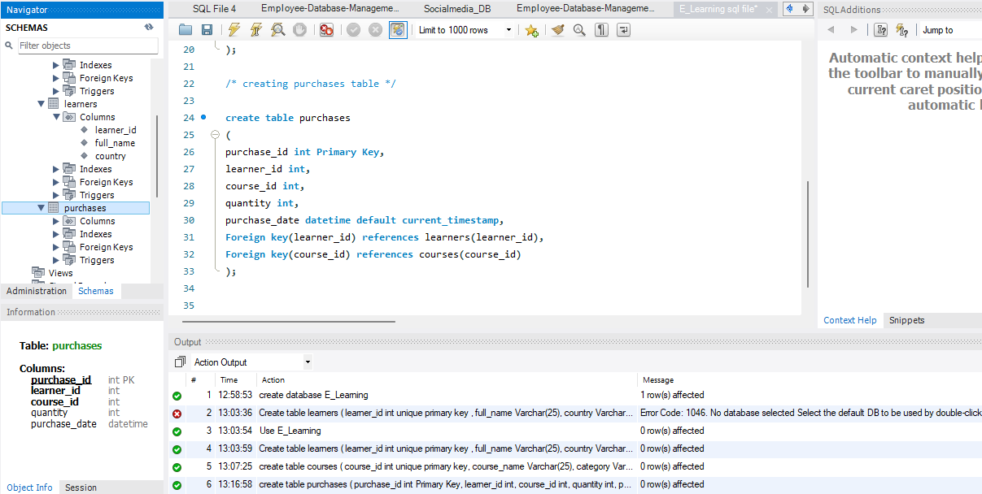

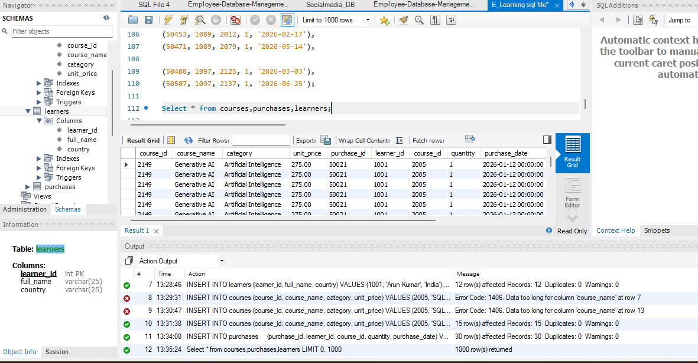

2. Data Exploration Using Joins
Inner join
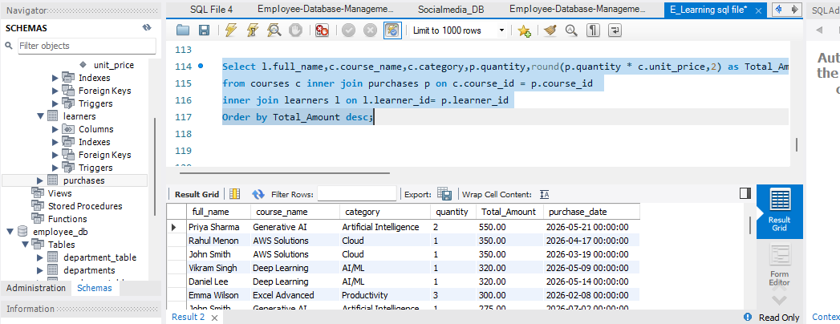
Left join

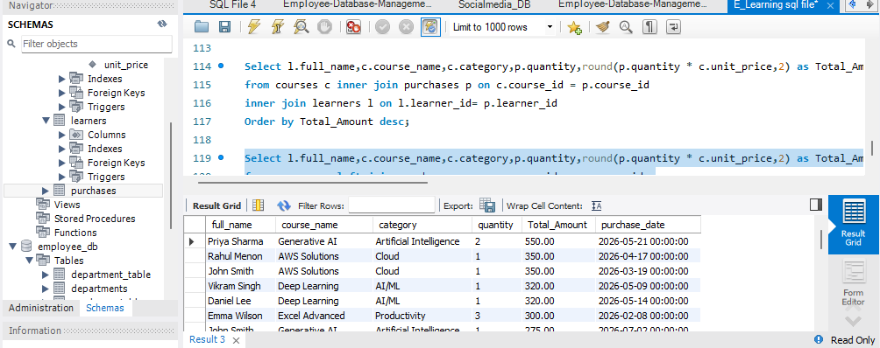

Right join

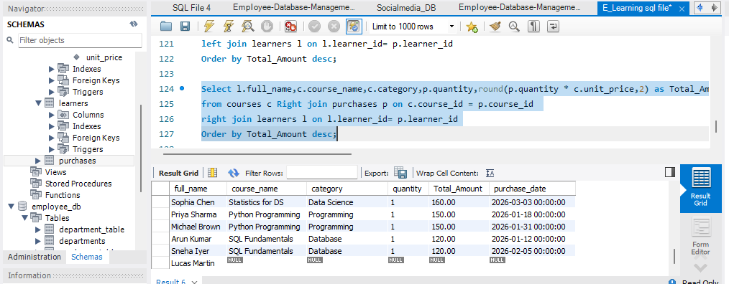
3. Core Analytical Queries (Q1–Q5)
Q1. Display each learner’s total spending with their country.
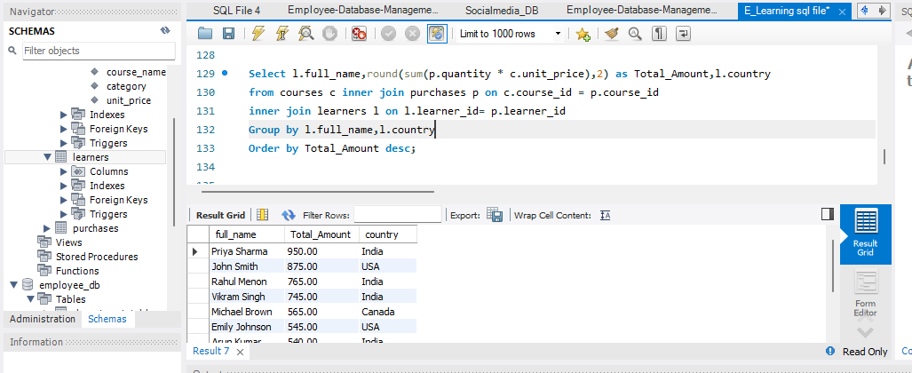
Q2. Find the top 3 most purchased courses by quantity.
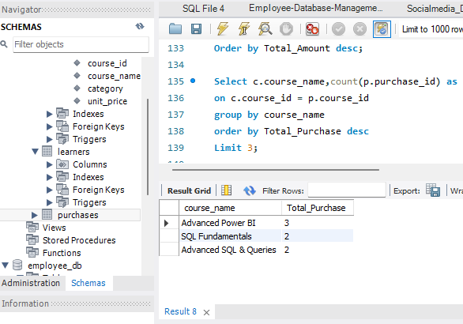

Q3. Show each category’s:
● Total revenue
● Number of unique learners

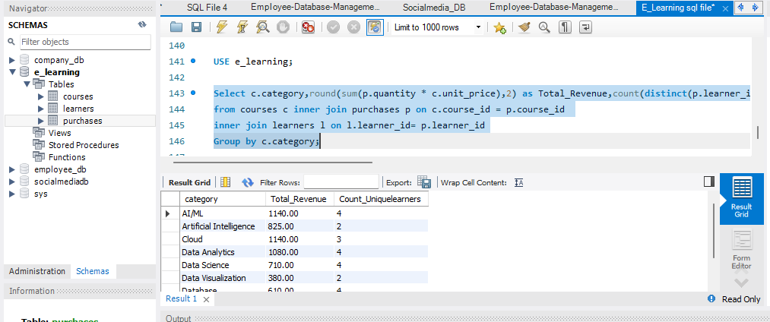

Q4. List learners who purchased from more than one category.

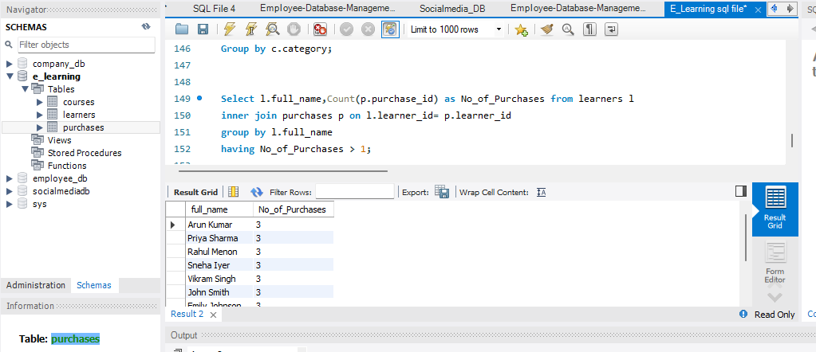

4. Subqueries & Correlated Subqueries
Q6. Find learners whose total spending is above the average learner spending.
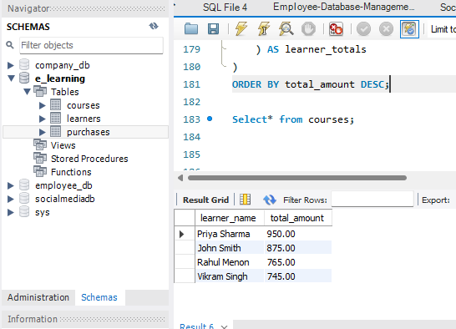

Q7. Display courses whose price is higher than any course in the ‘Beginner’ category.

current courses table doesn't have a Beginner/level field to answer these questions

Q8 . Find learners who spent more than the average spending in their country.

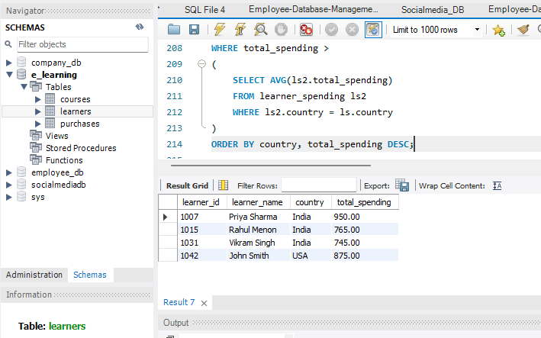
5. CTE, CASE, View, and NULL Handling
Q9. Use a CTE to calculate total spending per learner, then:
Display learners with spending above 10,000.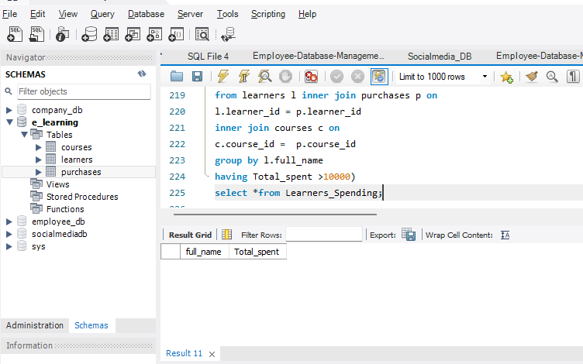
Q11 . NULL Handling

● Display all courses and replace NULL purchase counts with 0 using: IFNULL() or
COALESCE()
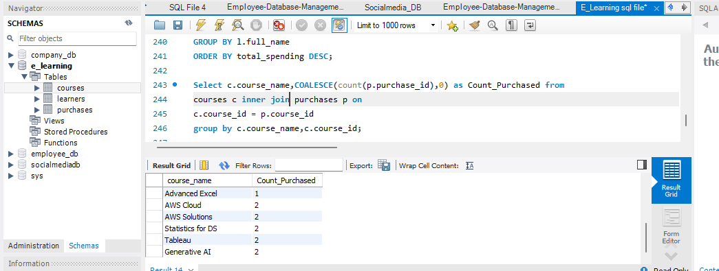

Q12 . View

● Create a view: category_performance_view
● Showing:
● Category
● Total revenue
● Number of purchases
● Average revenue per purchase

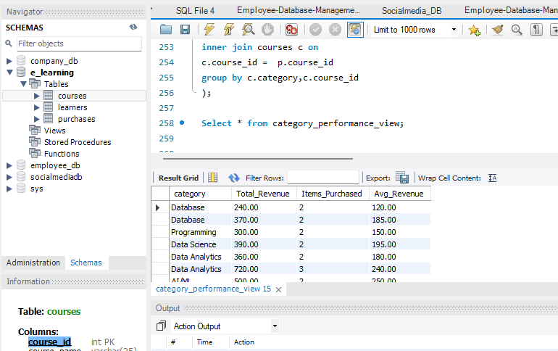

Key Business Insights
- Identify high-spending learners for retention and loyalty campaigns.
- Use High Value, Medium Value, and Low Value classifications to prioritize marketing efforts.
- Identify the most purchased courses and categories for future promotional campaigns.
- Identify courses with zero or low purchase activity for content, pricing, or marketing review.
- Compare learner spending across countries to identify stronger-performing markets.
- Use category revenue and average revenue per purchase to support course portfolio decisions.

Recommendations
- Focus retention and personalized offers on High Value learners.
- Use targeted campaigns to move Medium Value learners toward higher-value purchases.
- Review low-performing courses for pricing, content relevance, and discoverability.
- Invest in categories with strong revenue and purchase volume.
- Use country-level spending comparisons to tailor regional marketing strategies.

Conclusion
This project provided hands-on experience in SQL querying and business analysis using MySQL. It demonstrates the ability to create and query a relational learner purchase database, combine related data using JOIN operations, calculate business metrics using aggregate functions, and perform comparative analysis using subqueries and CTEs. The project also strengthened practical understanding of CASE expressions, NULL handling, and Views for reusable analytical reporting. Overall, the assignment establishes a strong foundation for SQL-based data analytics and business intelligence.

